1. What is LINQ Min Method in C#?

The LINQ Min Method belongs to the category of Aggregate Operators. This method is used to return the smallest numeric value from the collection on which it is applied.

1. Example to Understand Min Method in C#:

Let us understand the LINQ Min() method with Examples in C# using both Method and Query Syntax. The following example returns the smallest number from the collection using both query and method syntax. The point that you need to remember is the Min Method is going to work with numeric values only. In this case, the collection stores integer values, and hence we can apply the Min Method. We don’t have any operator called min in the Query Syntax. So here we need to use mixed syntax.

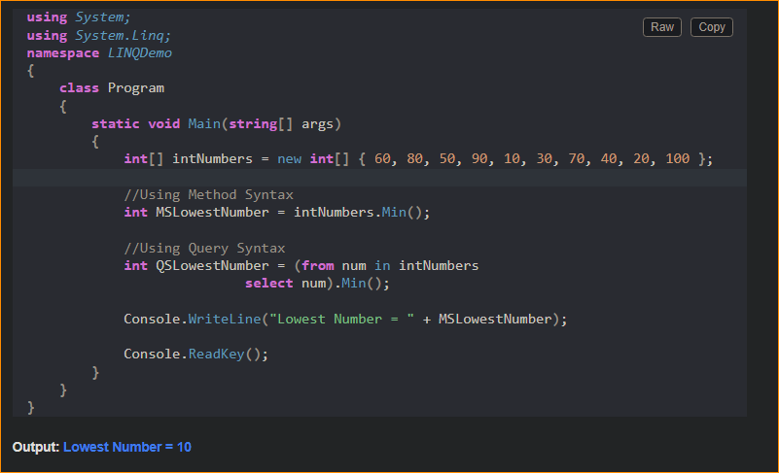

1. Example to Understand LINQ Min Method with Where Extension Method using C#

Let us see an example to Understand how we can use the LINQ Min Method along with the Where Extension Method in C# using both Method and Query Syntax. Now our requirement is to return the smallest number from the collection where the number is greater than 50. The following example code exactly does the same.

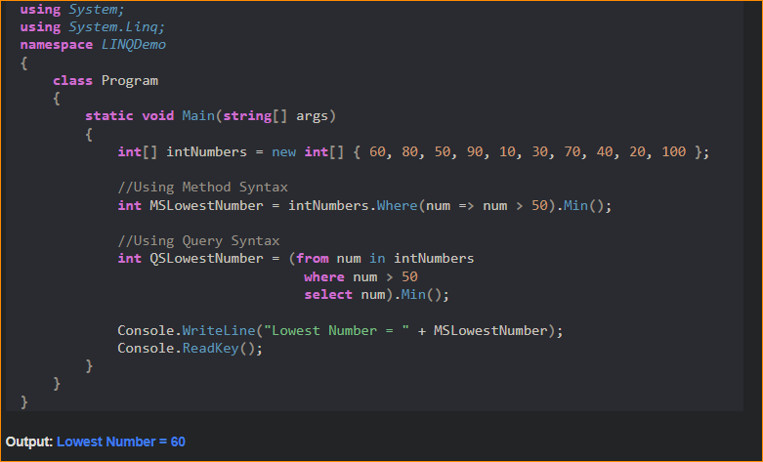

1. Example to Understand How to use LINQ Min Method with Predicate in C#

Let us see an example to Understand How to use LINQ Min Method with Predicate in C# using both Method and Query Syntax. Instead of using the Where Extension method to filter the data, we can also use the other overloaded version of the Min Extension method which takes a Predicate as a parameter, and using the predicate, we can write the logic to filter the data. In the below example, within the Min Method, we are using a Predicate and we are providing the condition whether the number is greater than 50 or not. If the number is greater than 50, then we are returning that number else we are returning 0. The following example will return the smallest number which is greater than 50.

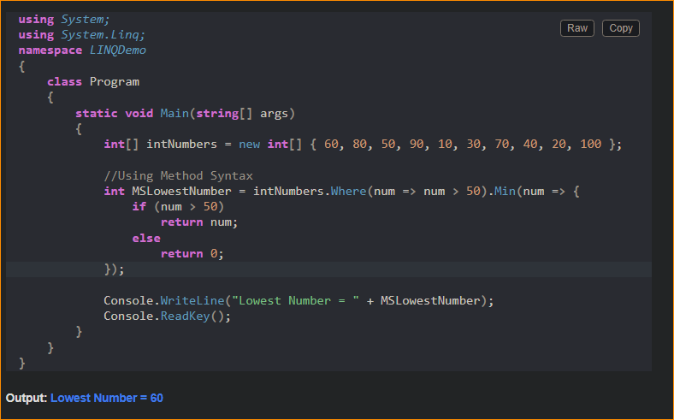

1. Example to Understand LINQ Min Method with Complex Type in C#:

Let us see an example to Understand How to use LINQ Min Method with Complex Data Type in C# using both Method and Query Syntax. We are going to work with the following Employee class. As you can see, it is a very simple class having four properties such as ID, Name, Salary, and Department. Here, we also created one method i.e. GetAllEmployees() which will return the list of all the employees and this is going to be our data source.

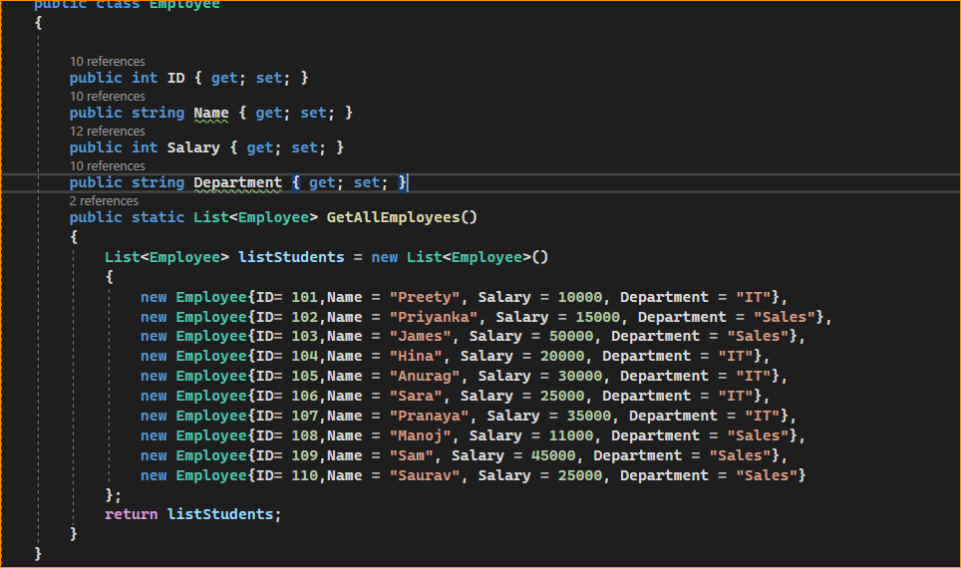

Now, our requirement is to return the lowest salary among all the employees. The following example returns the lowest salary among all the employees using both Method and Query Syntax. Here, to the Min method, we are specifying the numeric Salary column using a lambda expression.

